Growth of International Players in Baseball

1. INTRODUCTION

In recent years, Major League Baseball (MLB) teams are sending scouts to look for international prospects to bolster their teams. With a focused effort on finding prospects outside of the US, baseball has become more than “America’s Pastime.” In MLB history, which decades had the greatest amount of internationally born players? Of the decades with highest international born players, which countries had the most players in the league?

1. DATASET

“Appearances” and “Master” datasets were used for this analysis. The Appearances Dataset provides which years a players played in and the Master Dataset contains birth information about the players.

1. DATA PREPERATION

Since the MLB was founded in 1903, the “Appearance” dataset were modified to only include players that played in 1903 to 2014. Game starts and games as designated hitter, pinch hitter, and pinch runner had missing values in seasons before 1974. This analysis is looking for unique players by decade, those variables will not be used.

In the “Masters” dataset, most columns have blank values. In this dataset, only the player ID and birth country columns will be merged into the “Appearance” dataset. To clean the birth country, we will fill the blank values with the value “Unknown.”

1. ANALYSIS

The contribution of data grows every year. There are some interesting peaks during the 1884, 1914, and 1915 seasons. A deeper look into the data, and those seasons included data from defunct baseball leagues. Since this analysis will only be on MLB data, all leagues except NL and AL will be filtered out.

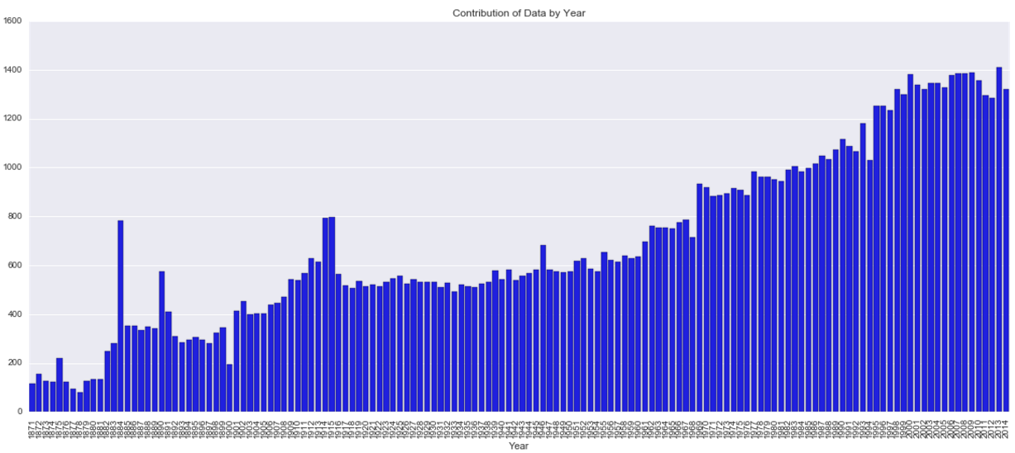

After the 1930’s, there was a steady increase of international born players in the league. The 1990s to 2010s had the greatest amount of internationally born players.

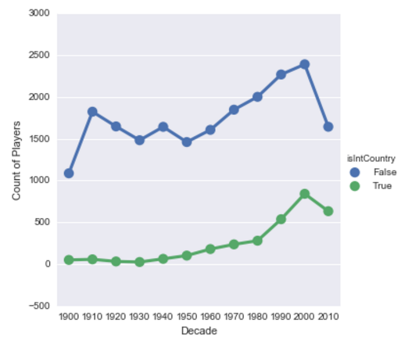

Looking at the above chart by ratio instead of count of international born players, we can see that 2010 has the highest ratio of international born players out of all the decades.

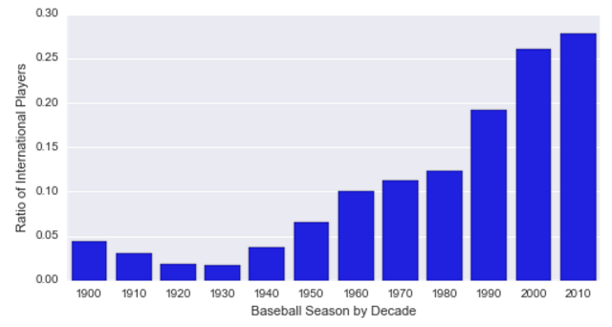

On average, the Dominican Republic, Venezuela, and Puerto Rico had the most players in the league by year during the 1990 to 2010 decades.

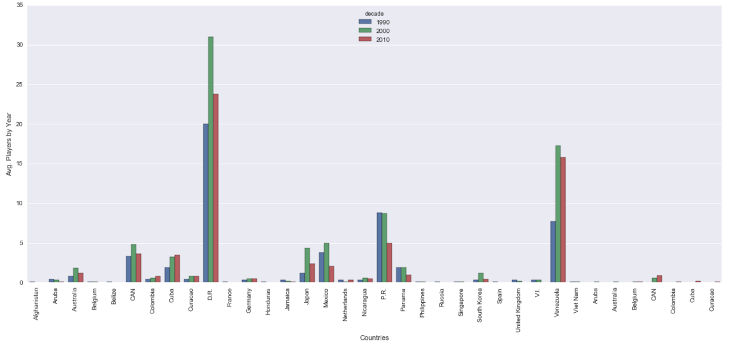

1. CONCLUSION

MLB started to see a large influx of internationally born players starting in the 1990’s and continued growth in the 2010’s. A large portion of these players come from the Dominican Republic and Venezuela.

Some limitations found while during this analysis was an incomplete 2010 decade. Though it looks like international growth will continue in the 2010s, it could fluctuate positively or negatively years after 2014. It will be useful to include length of career as a variable. Longevity of career would help us understand if international players are sticking in the league longer than US born players.

Sources

Download Lahman’s Baseball Database. (n.d.). Retrieved July 07, 2016, from http://www.seanlahman.com/baseball-archive/statistics/

National League of baseball is founded. (n.d.). Retrieved July 06, 2016, from http://www.history.com/this-day-in-history/national-league-of-baseball-is-founded